# Aura jack Pierre Watches, Strap, Watch Strap

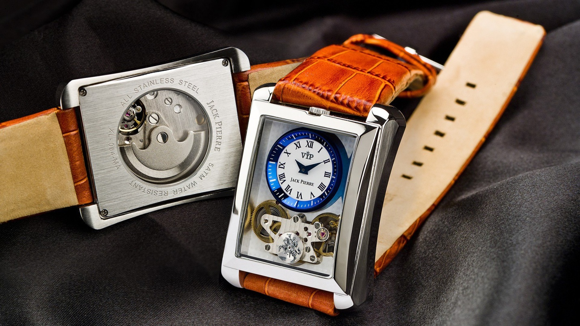

Details About This Watch:

Crystal: Domed Sapphire  
Case Material: 316L Stainless steel  
Case S

***Specs***

**CASE SHAPE:**Round

**CASE MATERIAL:**Stainless Steel

**MOV'T TYPE:**Quartz

**STRAP MATERIAL:**Leather

***Price***

***Rs:6,500***